WOMEN’S UNIVERSITY IN
AFRICA


Addressing gender disparity and fostering equity in University Education
FACULTY OF MANAGEMENT AND ENTREPRENEURIAL
SCIENCES

NAME: NOMSA S M WIZALAMU
LEVEL: 1.2
DEGREE: INFORMATION SYSTEMS
COURSE: KIS213 SOFTWARE ENGINEERING
STUDENT ID: W251190
LECTURER: MR MUSHONGA

DUE DATE: 30 APRIL 2026

INDIVIDUAL PROJECT

Week 1: Setting up Development Environments & Git Lab 1: Git Basics & Environment
• Install Git, VS Code (or PyCharm), and create a GitHub account.
• Configure Git (user.name, user.email).
• Create a local repo, add a README.md, commit, and push to GitHub.
• Practice: Clone a repo, make a change, commit, and push.

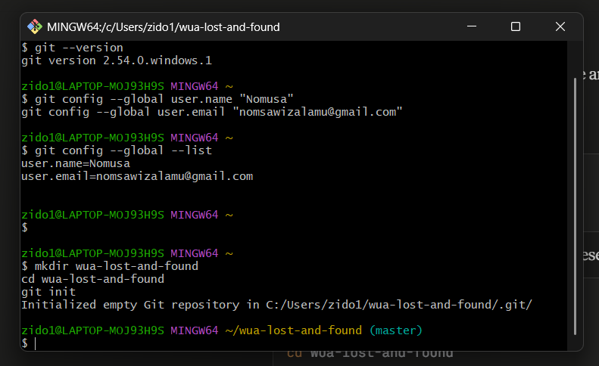

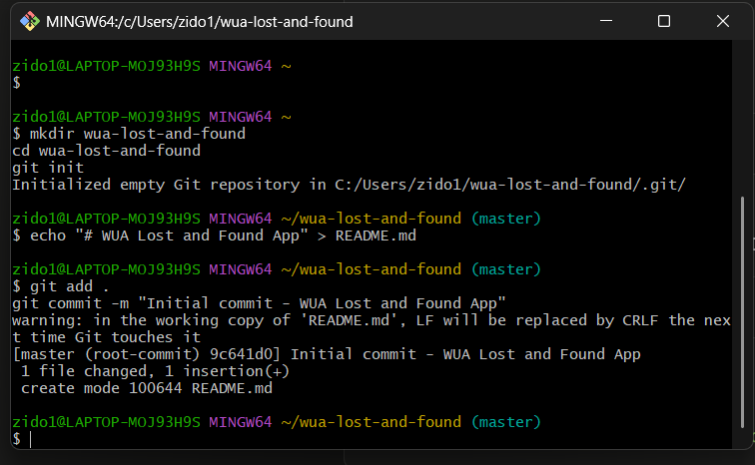

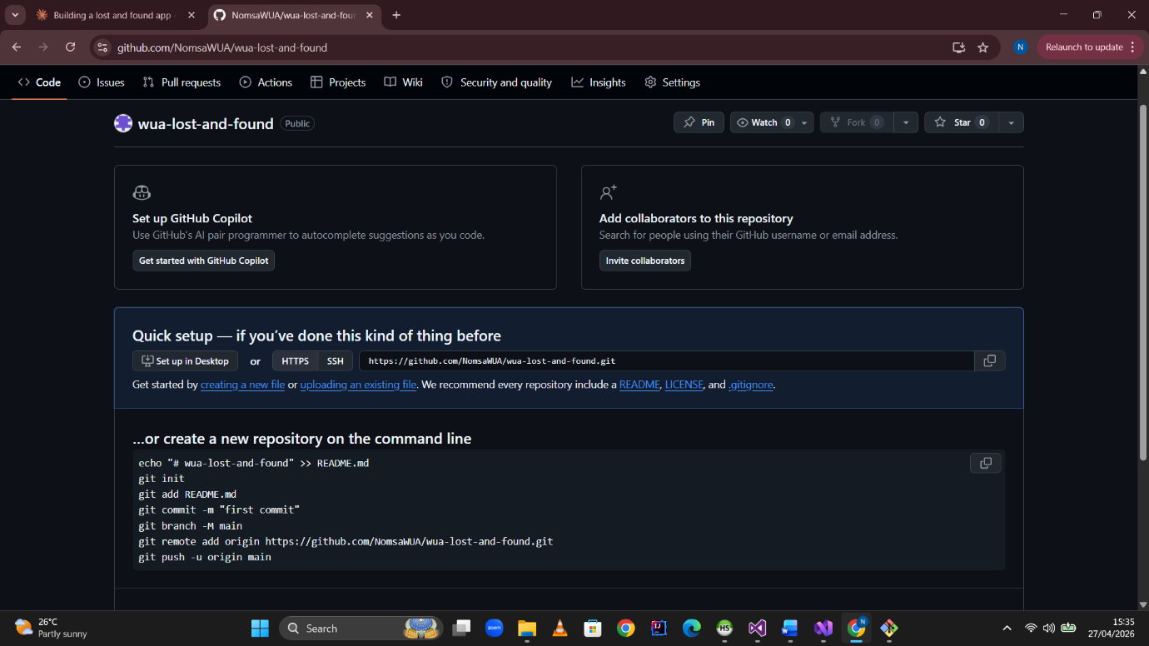

Week 2: Team Project Kick-off & Product Backlog
Lab 2: Creating a Product Backlog in GitHub Projects
• Create a GitHub repo for your team project.
• Use GitHub Issues or Trello to create a product backlog (10–15 user stories).
• Label stories as Must-have, Should-have, Could-have.
• Prioritize using MoSCoW method

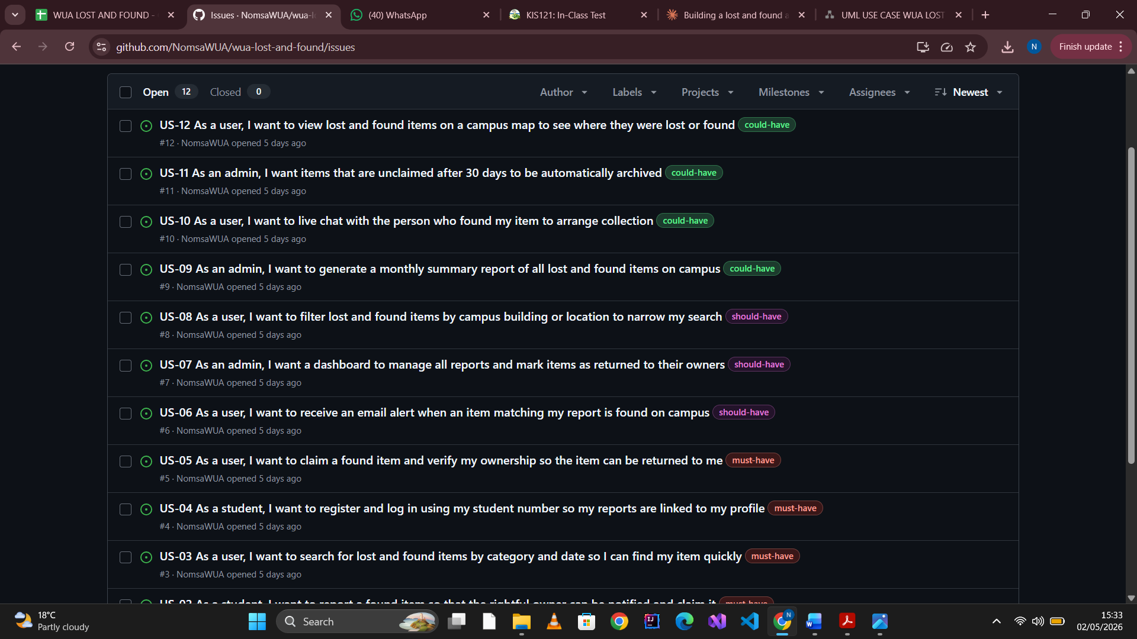

Week 3: Project Proposal & Planning
Lab 3: Writing a Mini Project Proposal
Write a 1-page proposal: problem statement, objectives, scope, key features.
Create a Gantt chart using Google Sheets or a tool like GanttProject.
• Identify 3–5 risks and mitigation strategies

1. Problem Statement
Women's University in Africa (WUA) is a vibrant campus environment with hundreds of students, lecturers, and staff moving through lecture halls, libraries, canteens, hostels, and administrative blocks every day. In such a dynamic setting, the loss of personal belongings is an inevitable and recurring challenge.

Currently, when a student or staff member loses an item on campus, there is no formal or centralised system to report it. Equally, when someone finds a lost item, they have no reliable way to locate the rightful owner. The existing informal approaches — pinning hand-written notes on noticeboards, word-of-mouth, or posting in WhatsApp groups — are unreliable, slow, and easily missed.

As a result, WUA has no dedicated, accessible platform for reporting, searching, and recovering lost and found items on campus. This leads to permanent loss of valuable items such as student ID cards, laptops, phones, and stationery, wasted time visiting the security office, and found items going unclaimed and being discarded or misappropriated.

2. Objectives
The main objectives of the WUA Lost and Found Web Application are:
- To provide a centralised, browser-accessible platform for reporting lost and found items on campus.
- To enable students and staff to search for their lost items using filters such as category, date, and location.
- To implement a secure ownership verification system that allows users to claim found items.
- To notify users automatically via email when a matching item is reported found.
- To give WUA security staff an admin dashboard to manage all reports and mark items as returned.

3. Scope

3.1 In Scope
- A web-based application accessible from any browser on desktop and mobile.
- User registration and login using WUA student or staff number.
- Forms to report lost items and found items with photo upload support.
- A searchable, filterable database of all reported items.
- A claim request system with security question verification.
- Email notifications when a matching item is found.
- An admin dashboard for WUA security staff.

3.2 Out of Scope
- A native mobile application (iOS or Android) — the web app will be mobile-responsive.
- Integration with WUA's existing student information systems.
- Real-time live chat between users (planned for a future version).
- Physical item tracking using QR codes or RFID technology.

4. Key Features
The following key features will be implemented in the first version (v1) of the application:

# | Feature | Description
F-01 | User Authentication | Secure login and registration using WUA student/staff number with bcrypt password hashing.
F-02 | Report Lost Item | Students submit item name, category, date, location, description and optional photo.
F-03 | Report Found Item | Users log found items with the same details, specifying where the item is being held.
F-04 | Search & Filter | Keyword search with filters for category, date range, campus location, and item type.
F-05 | Claim Request | Logged-in users can submit a claim; the system prompts ownership verification questions.
F-06 | Email Notifications | Automated email alerts when an item matching a lost report is added to the system.
F-07 | Admin Dashboard | Security staff can manage all reports, review claims, and mark items as returned.

5. Technology Stack
- Frontend: HTML5, CSS3, JavaScript — for the user interface, accessible in any browser.
- Backend: Node.js with Express.js — handles API requests and business logic.
- Database: MySQL — stores users, item reports, claims, and notifications.
- Authentication: bcrypt for password hashing; express-session for session management.
- File Uploads: Multer — handles photo uploads of lost and found items.
- Version Control: Git and GitHub — for source code management and collaboration.
- Testing: Jest — for writing and running unit tests on core functions.
- CI/CD: GitHub Actions — automates test runs on every code push.

6. Risk Identification & Mitigation

Risk | Likelihood | Impact | Mitigation Strategy
Low student adoption of the platform | Medium | High | Run a campus awareness campaign; ensure the app works well on mobile phones.
Fake ownership claims by wrong persons | High | High | Implement security question verification; admin must approve all claims before handover.
Database data loss or corruption | Low | High | Schedule daily MySQL backups; use GitHub for code version control.
Scope creep — adding too many features | Medium | Medium | Stick strictly to Must-have user stories for v1; defer Could-have features to v2.
Deployment issues on hosting platform | Low | Medium | Test locally first using XAMPP; deploy to Render.com which offers a free Node.js hosting tier.

7. Proposed Timeline
The project will be completed over 10 weeks following the assignment schedule:

Week 1 | Git setup, VS Code, Node.js installation, GitHub repository creation
Week 2 | Product backlog creation with 12 user stories using MoSCoW prioritisation
Week 3 | Mini project proposal and Gantt chart (this document)
Week 4 | Use case descriptions and UML Use Case Diagram
Week 5 | UML Class Diagram and Sequence Diagram
Week 6 | Architectural design — MVC pattern with component diagram
Week 7 | Implementation of Factory design pattern with code refactoring
Week 8 | Unit testing with Jest — edge cases and test-driven development
Week 9 | CI/CD pipeline setup with GitHub Actions
Week 10 | Sprint planning with Trello — sprint backlog and story point estimation

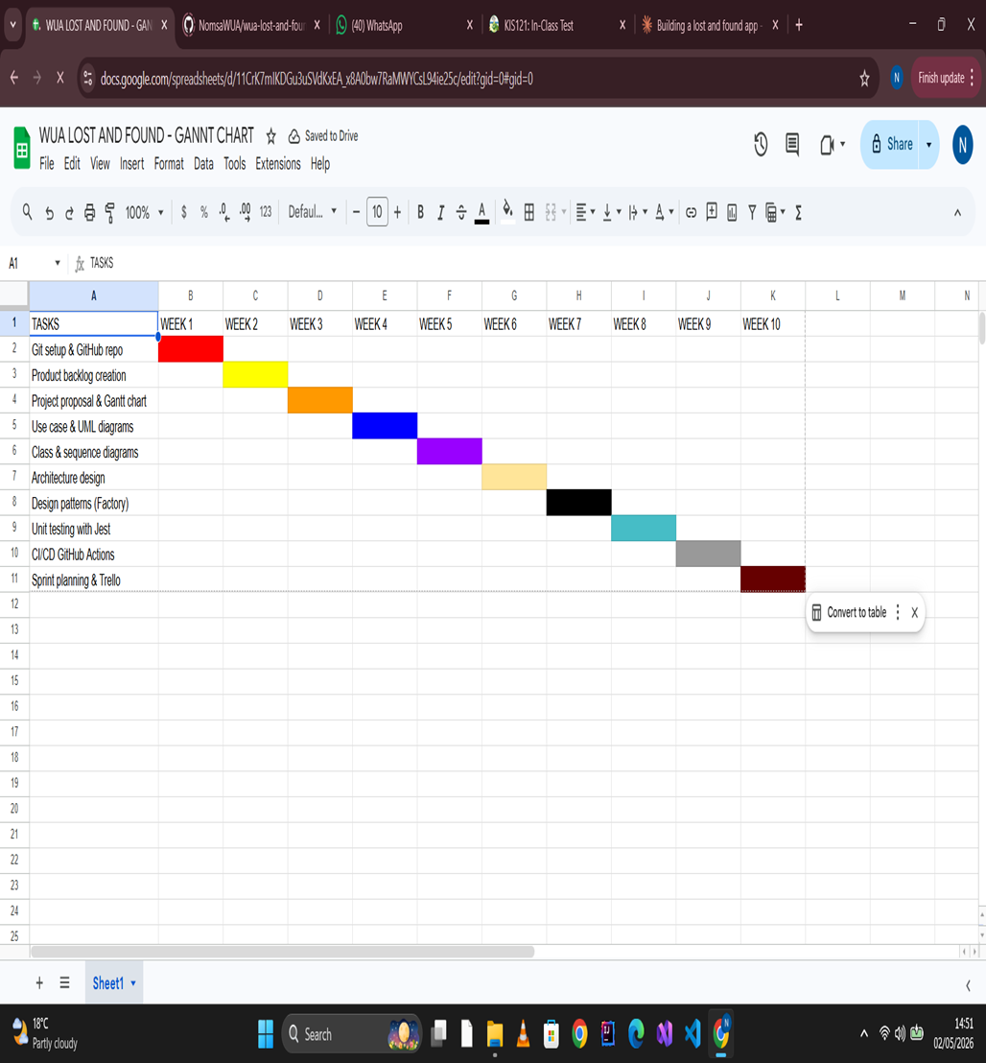


Week 4: Requirements & Use Case Modeling
Lab 4: Writing Use Cases & Drawing UML Use Case Diagram
• Pick 3 user stories from your backlog.
UC-01: Report Lost Item
Field | Detail
Use Case ID | UC-01
Use Case Name | Report Lost Item
Actor | Student
Precondition | Student is logged into the system
Trigger | Student clicks "Report Lost Item" button
Main Flow:
- Student clicks "Report Lost Item" on the homepage
- System displays the report form
- Student enters item name, category, description, date lost and location
- Student optionally uploads a photo of the item
- Student clicks "Submit Report"
- System saves the report to the database
- System generates a unique reference number
- System displays confirmation message with reference number
Alternate Flow:
- If photo upload fails → system saves report without photo and notifies user
- If required fields are empty → system highlights missing fields and asks user to complete them
Postcondition: Lost item report is saved and appears in search results
UC-02: Search for Lost or Found Items
Field | Detail
Use Case ID | UC-02
Use Case Name | Search Items
Actor | Student or Staff (logged in or not)
Precondition | None — search is available to all visitors
Trigger | User enters a keyword in the search bar

Main Flow:
- User types a keyword in the search bar
- User selects optional filters — category, date, location
- User clicks "Search"
- System queries the database for matching items
- System displays a list of matching lost and found items
- User clicks on an item to view full details
Alternate Flow:
- If no results found → system displays "No items found matching your search"
- If user clears filters → system displays all items
Postcondition: User sees a list of items matching their search criteria
UC-03: Claim a Found Item
Field | Detail
Use Case ID | UC-03
Use Case Name | Claim Found Item
Actor | Student (logged in)
Precondition | Student is logged in and a matching found item exists in the system
Trigger | Student clicks "Claim This Item" on a found item listing
Main Flow:
- Student finds their item in the search results
- Student clicks "Claim This Item"
- System displays a claim form with 2 security questions
- Student answers the questions to prove ownership
- Student clicks "Submit Claim"
- System saves the claim and notifies admin
- Admin reviews the claim and approves or rejects it
- System notifies student of the outcome via email
Alternate Flow:
- If security answers are incorrect → claim is rejected and student is notified
- If student is not logged in → system redirects to login page first
Postcondition: Claim is submitted and awaiting admin approval. If approved, item is marked as returned.

• Write detailed use case descriptions (pre/post conditions, main flow, and alternate flows).
USE CASE 1: Report Lost Item
Use Case ID: UC-01 Use Case Name: Report Lost Item Actor: Student Description: This use case allows a logged-in student to report an item they have lost on the WUA campus by filling in a form with details about the item.
Preconditions:
- The student must be registered and logged into the system
- The system must be connected to the database
Postconditions:
- The lost item report is saved in the database
- The item appears in the public search results
- A unique reference number is generated and shown to the student
Trigger: Student clicks the "Report Lost Item" button on the homepage
Main Success Flow:
Step | Actor Action | System Response
1 | Student clicks "Report Lost Item" | System displays the report form
2 | Student enters item name and category | System validates the fields in real time
3 | Student enters description, date lost and campus location | System keeps fields active
4 | Student uploads an optional photo | System previews the uploaded image
5 | Student clicks "Submit Report" | System validates all required fields
6 | — | System saves the report to the database
7 | — | System generates a unique reference number
8 | — | System displays a success message with the reference number
Alternate Flows:
AF-01: Photo upload fails
- At step 4, if the image is too large or wrong format
- System shows an error message
- Student can proceed without a photo
- Report is saved without an image
AF-02: Required fields missing
- At step 5, if any required field is empty
- System highlights the missing fields in red
- System displays "Please complete all required fields"
- Student fills in the missing information and resubmits
AF-03: Session expires
- At any step, if the student's session has expired
- System redirects the student to the login page
- After logging in, student is returned to the form
Exception Flows:
EF-01: Database error
- System displays "Something went wrong, please try again"
- Report is not saved
- Student is advised to try again or contact admin
USE CASE 2: Search for Lost or Found Items
Use Case ID: UC-02 Use Case Name: Search Items Actor: Any user — Student, Staff, or Visitor (login not required) Description: This use case allows any user to search the database of reported lost and found items using keywords and filters to find a specific item.
Preconditions:
- The system must be running and connected to the database
- At least one item must exist in the database (otherwise results will be empty)
Postconditions:
- A list of matching items is displayed to the user
- If no items match, a "no results" message is shown
Trigger: User enters a keyword in the search bar and clicks "Search"
Main Success Flow:
Step | Actor Action | System Response
1 | User navigates to the search page | System displays the search bar and filter options
2 | User types a keyword | System shows a live preview of matching items
3 | User selects filters — category, date, location, type | System updates the filter options
4 | User clicks "Search" | System queries the database
5 | — | System returns a list of matching lost and found items
6 | User clicks on an item | System displays the full item details page
7 | Logged-in user clicks "Claim This Item" | System navigates to the claim form
Alternate Flows:
AF-01: No results found
- At step 5, if no items match the search
- System displays "No items found matching your search"
- System suggests the user broaden their search or report their item
AF-02: User clears all filters
- System resets and displays all items in the database
- Items are sorted by most recently reported
AF-03: User searches with no keyword
- System returns all items filtered only by the selected filters
- If no filters selected, all items are shown
Exception Flows:
EF-01: Database connection fails
- System displays "Unable to load results, please try again later"
- Search results page shows empty
USE CASE 3: Claim a Found Item
Use Case ID: UC-03 Use Case Name: Claim Found Item Actor: Student (primary), Admin (secondary) Description: This use case allows a logged-in student to submit a claim for a found item they believe is theirs. The admin reviews and approves or rejects the claim before the item is handed over.
Preconditions:
- Student must be registered and logged into the system
- A found item matching the student's lost item must exist in the database
- The found item must have a status of "Unclaimed"
Postconditions:
- If approved: item status changes to "Claimed" and student is notified to collect it
- If rejected: student is notified with the reason and may resubmit with more evidence
Trigger: Student clicks "Claim This Item" on a found item listing
Main Success Flow:
Step | Actor Action | System Response
1 | Student finds their item in search results | System displays the item details page
2 | Student clicks "Claim This Item" | System checks if student is logged in
3 | — | System displays the claim form with 2 security questions
4 | Student answers security questions and describes their proof of ownership | System keeps the form active
5 | Student clicks "Submit Claim" | System validates the form
6 | — | System saves the claim with status "Pending"
7 | — | System sends an email notification to admin
8 | Admin logs into dashboard and reviews the claim | Admin sees the claim details and student answers
9 | Admin clicks "Approve" | System updates item status to "Claimed"
10 | — | System sends approval email to student
11 | Student collects item from security office | Admin marks item as "Returned" in the system
Alternate Flows:
AF-01: Student not logged in
- At step 2, if student is not logged in
- System redirects to the login page
- After login, system returns student to the item details page
AF-02: Admin rejects the claim
- At step 9, admin clicks "Reject" and enters a reason
- System updates claim status to "Rejected"
- System sends rejection email to student with the reason given
- Student may submit a new claim with additional evidence
AF-03: Item already claimed by another student
- At step 2, if item status is already "Claimed"
- System displays "This item has already been claimed"
- Student cannot submit a new claim for this item
Exception Flows:
EF-01: Email notification fails
- System saves the claim successfully
- Admin is notified through the dashboard instead
- Student sees a message saying "Claim submitted — you will be contacted"

• Draw a UML use case diagram using draw.io or Lucidchart.
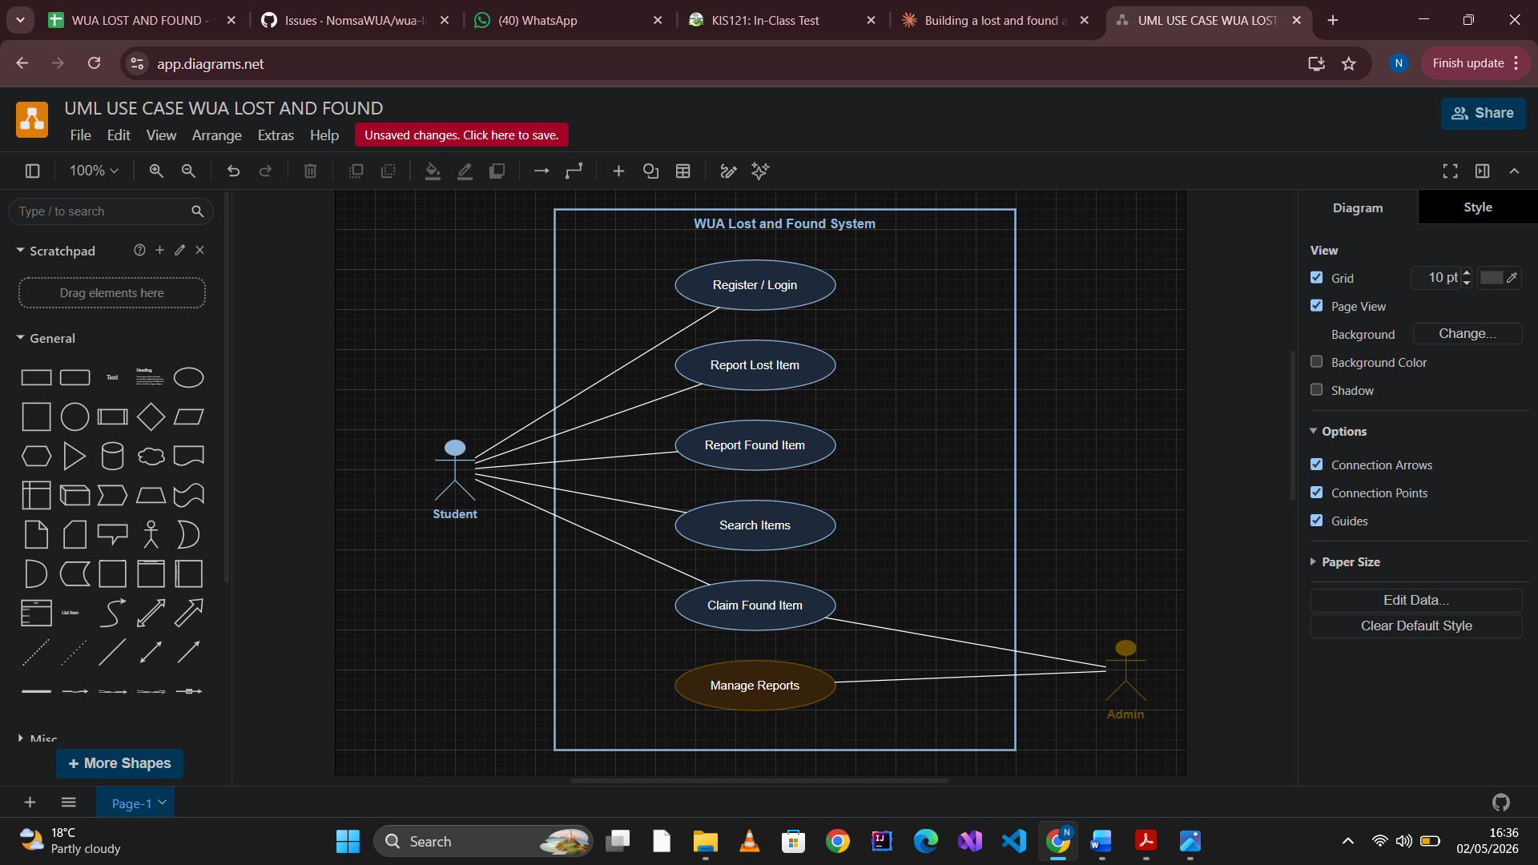

Week 5: Class & Sequence Diagrams
Lab 5: From Use Cases to Class Diagrams
• Identify 5–7 candidate classes from your use cases.
• Draw a UML class diagram (attributes, methods, relationships).
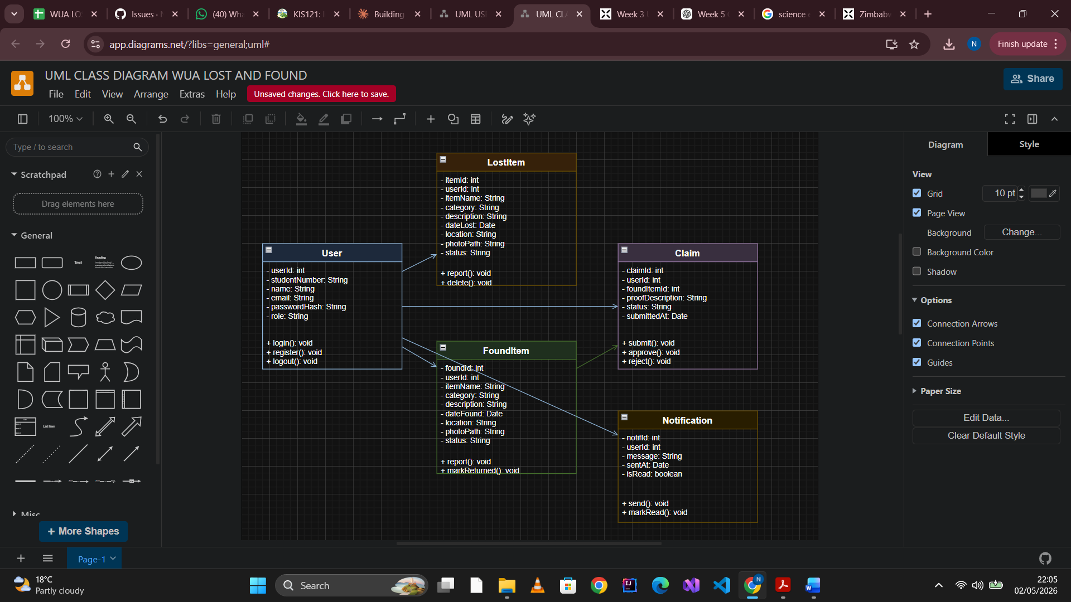
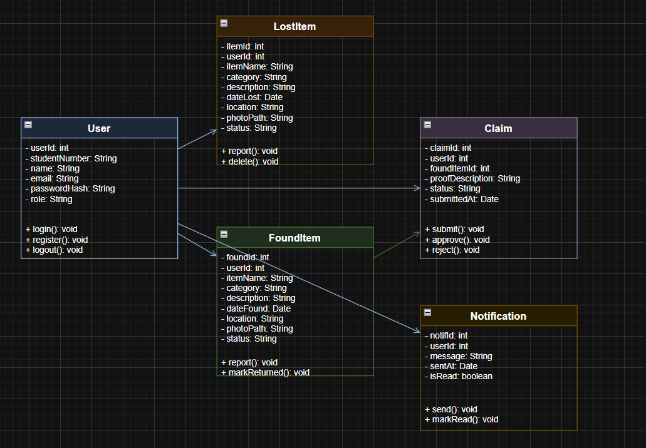

• Draw a sequence diagram for one use case
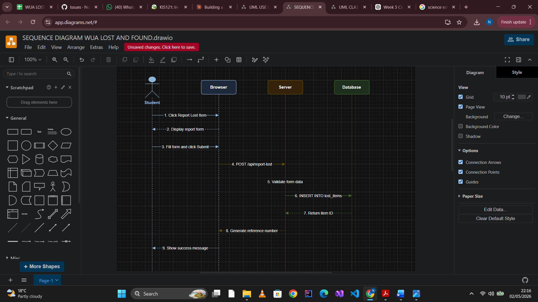
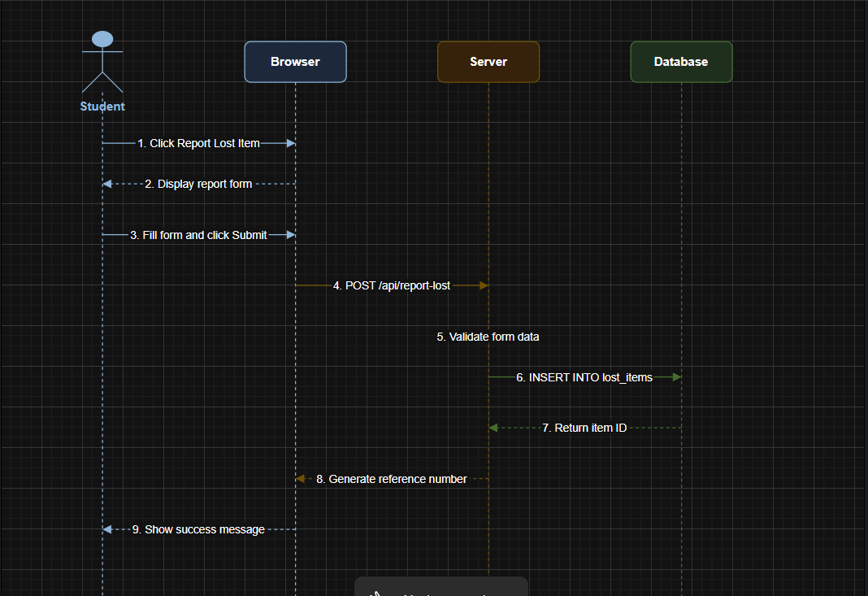

Week 6: Architectural Design

Lab 6: Choosing & Documenting Architecture
• Choose an architectural pattern (e.g., MVC/Microservices).
USE OF; MVC (Model-View-Controller)

• Draw a component/package diagram showing major modules.
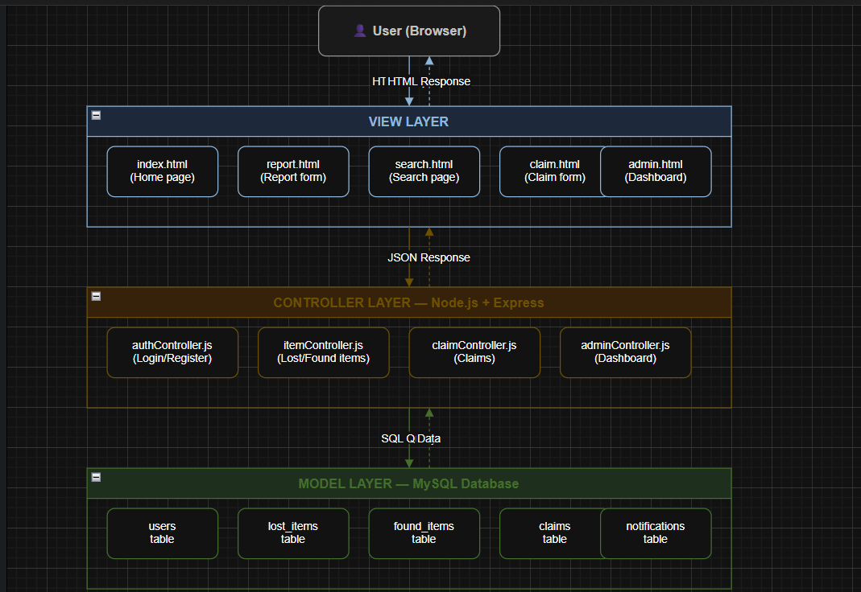

• Justify your choice based on non-functional requirements (e.g., scalability, security).

I chose MVC because:
1, It separates the HTML pages (View) from the business logic (Controller) and database (Model)
2.It makes the code easier to maintain — changing the database doesn't affect the HTML pages
3.It scales well as the app grows
4. It is the standard pattern for Node.js and Express applications
5. It improves security by keeping database logic away from the frontend

Week 7: Implementing a Design Pattern
Lab 7: Refactoring with a Design Pattern
  - • Given a small messy code snippet (e.g., a simple game or calculator), refactor using: o Singleton (e.g., config manager)
  - o Factory (e.g., creating different user types)
  - 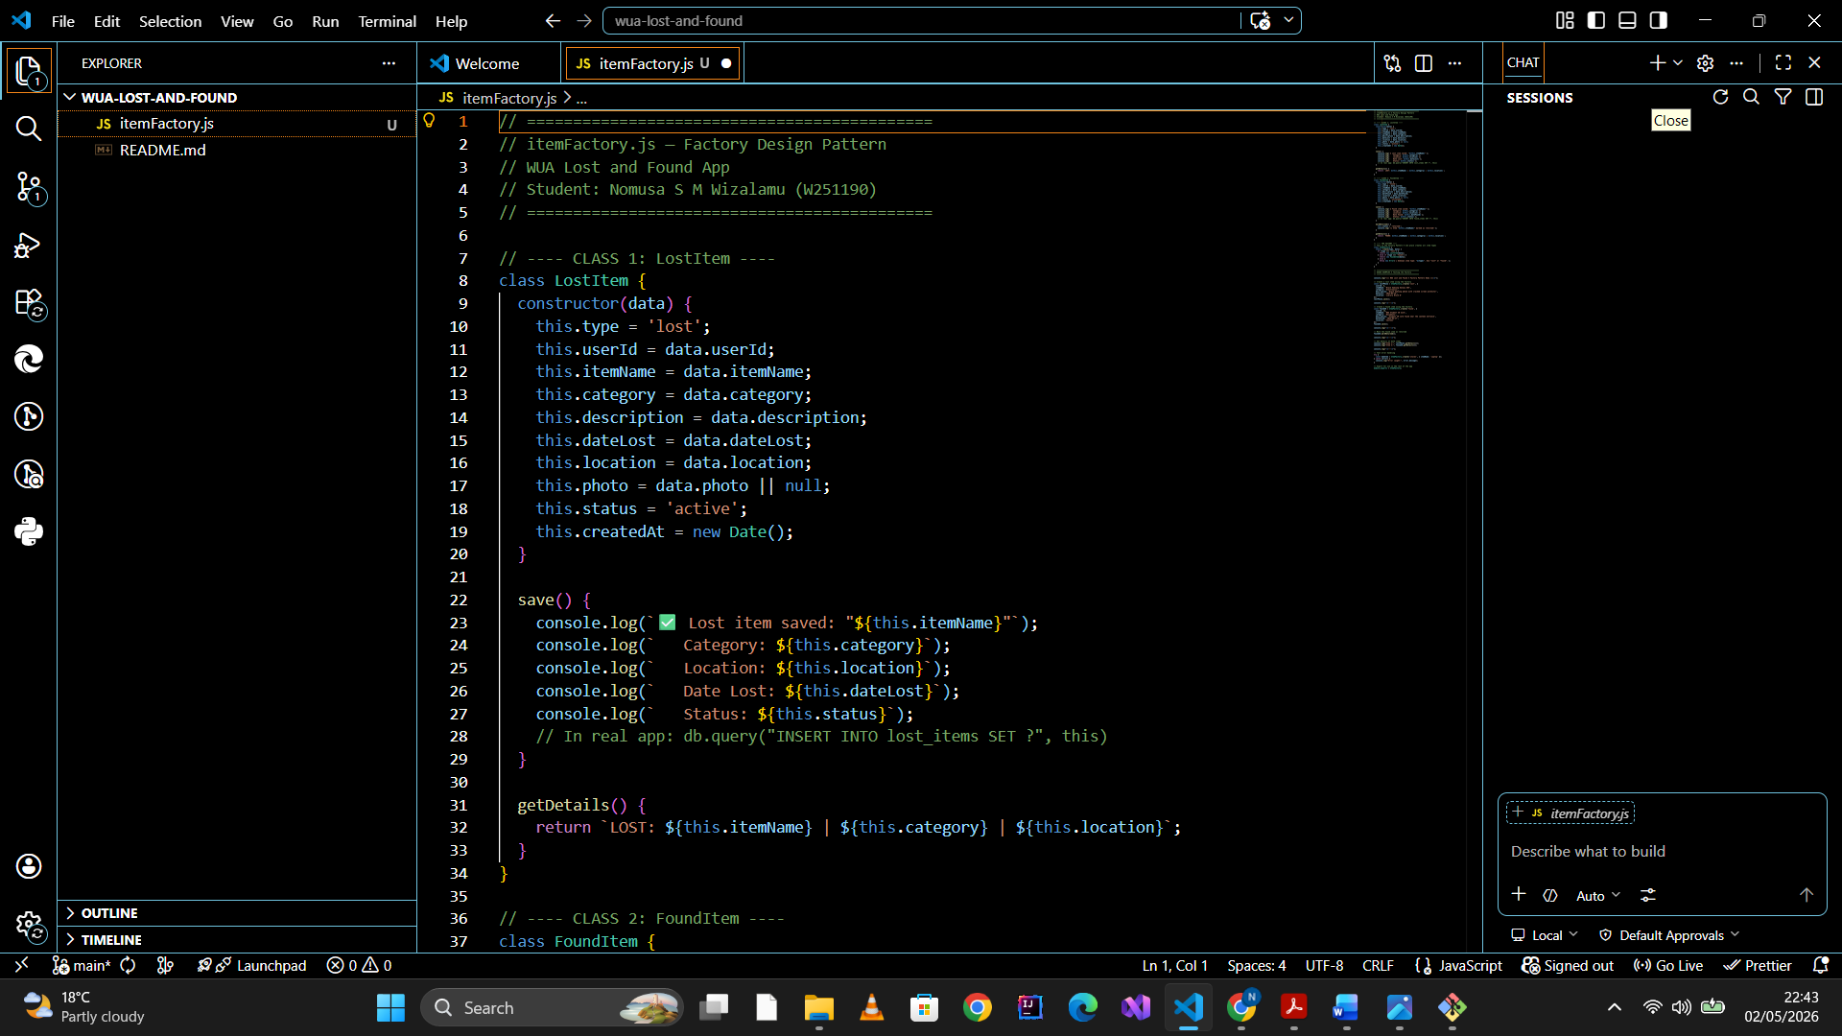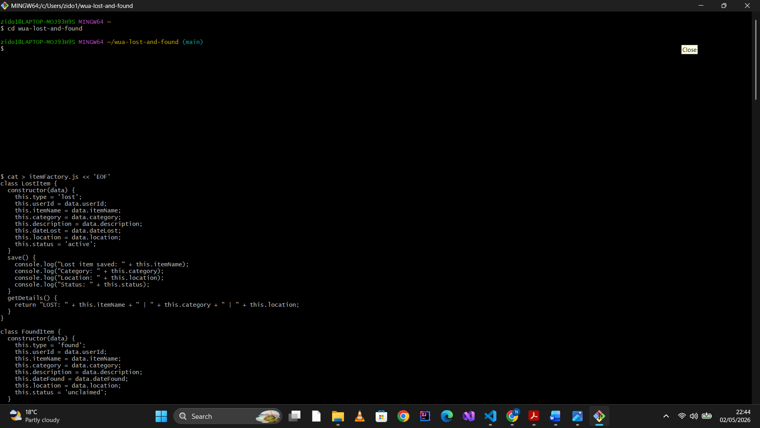
  - 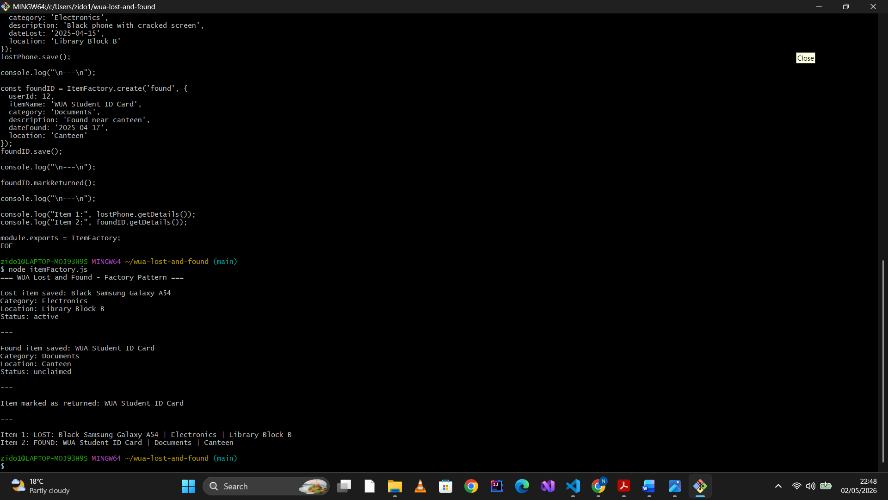
  - 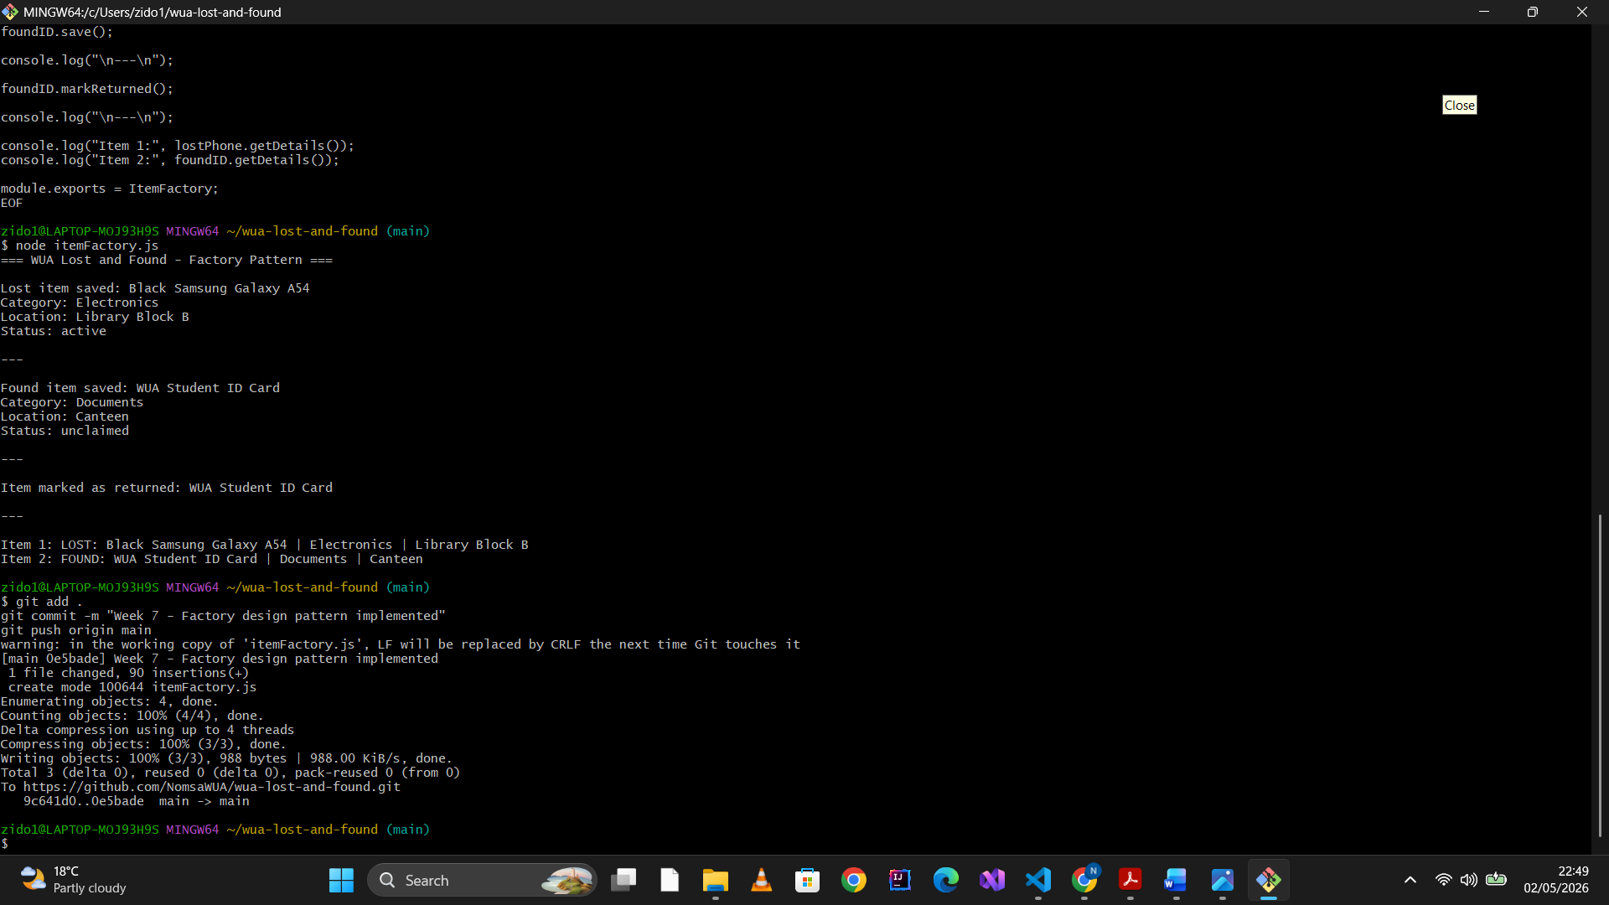
Reflection
Before using the Factory Pattern, every part of the code that needed to create an item had its own if/else block deciding whether to build a LostItem or FoundItem. This made the code messy and hard to maintain. After refactoring, all item creation goes through ItemFactory.create() — one clean line anywhere in the app. If a new item type needs to be added in future, only the factory class needs to change, not every file that creates items. The pattern improved the code by centralising object creation, reducing repetition, and making the codebase easier to extend and debug.

  - Week 8: Unit Testing with pytest/JUnit
  - Lab 8: Writing Unit Tests
  - • Write a simple function (e.g., calculate_tax(amount)).
  - • Write unit tests for edge cases (negative values, zero, large numbers).
  - • Run tests and fix failures.
  - • Optional: Try Test-Driven Development (write tests first, then code).
  - 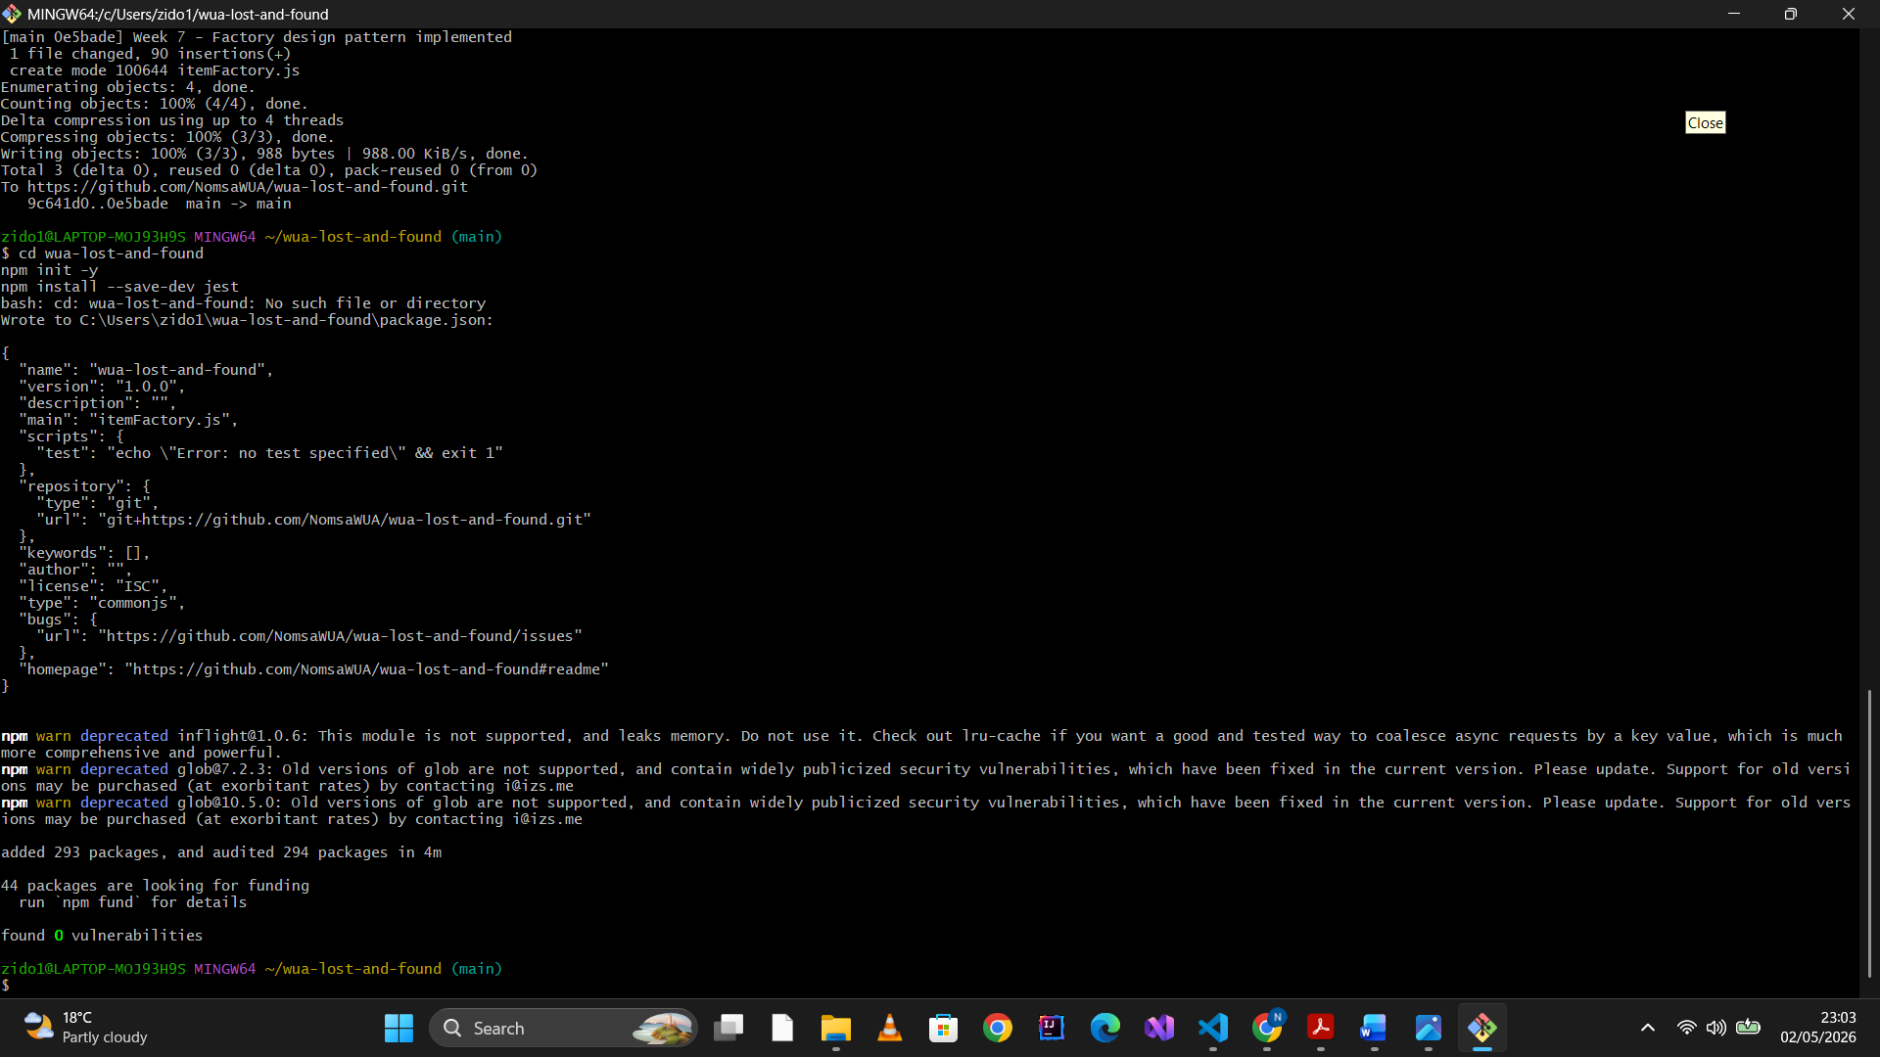
  - 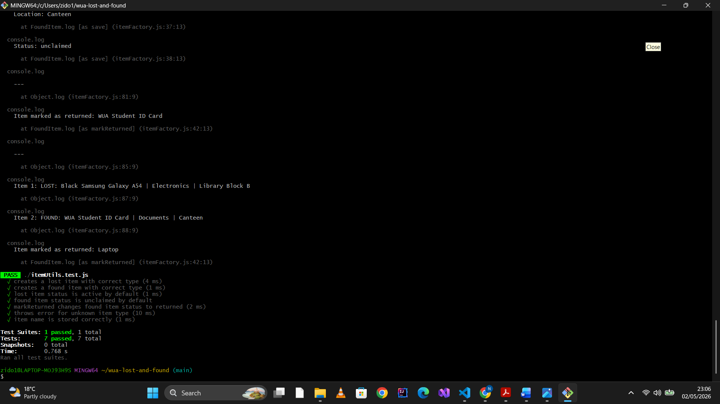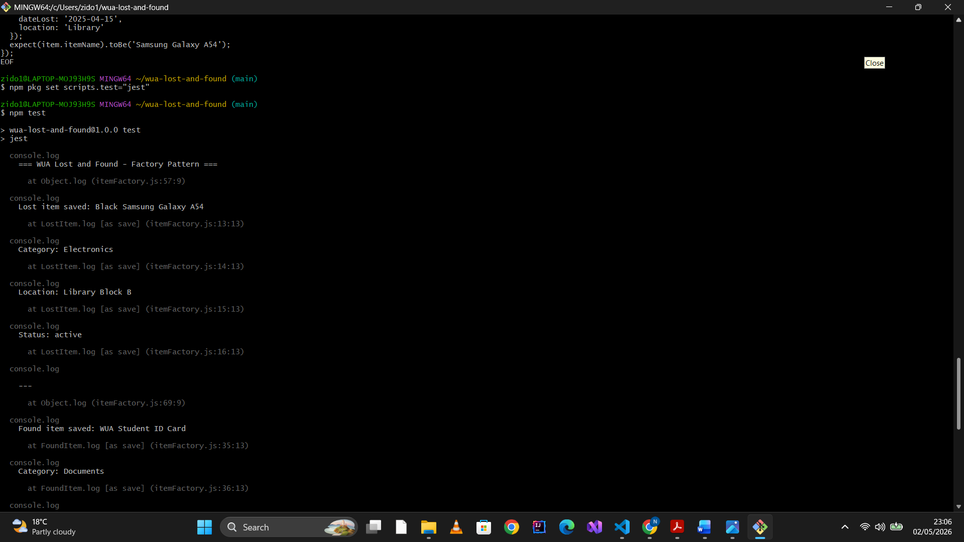

  - 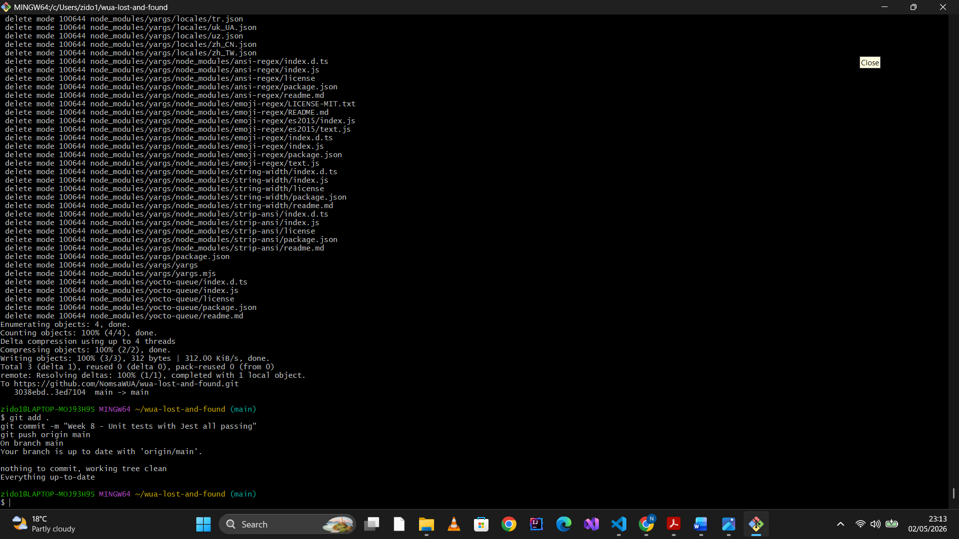

Week 9: CI/CD Pipeline with GitHub Actions
Lab 9: Automating Tests with GitHub Actions
- • Create a .github/workflows/test.yml file.
- • Configure it to run pytest or npm test on every push.
- • Break a test intentionally and see the pipeline fail.
- • Fix it and verify the pipeline passes.

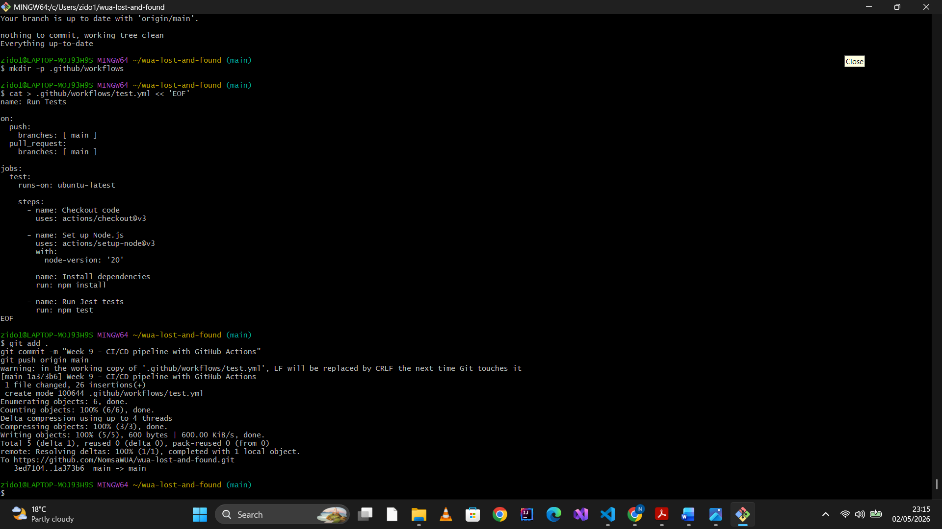
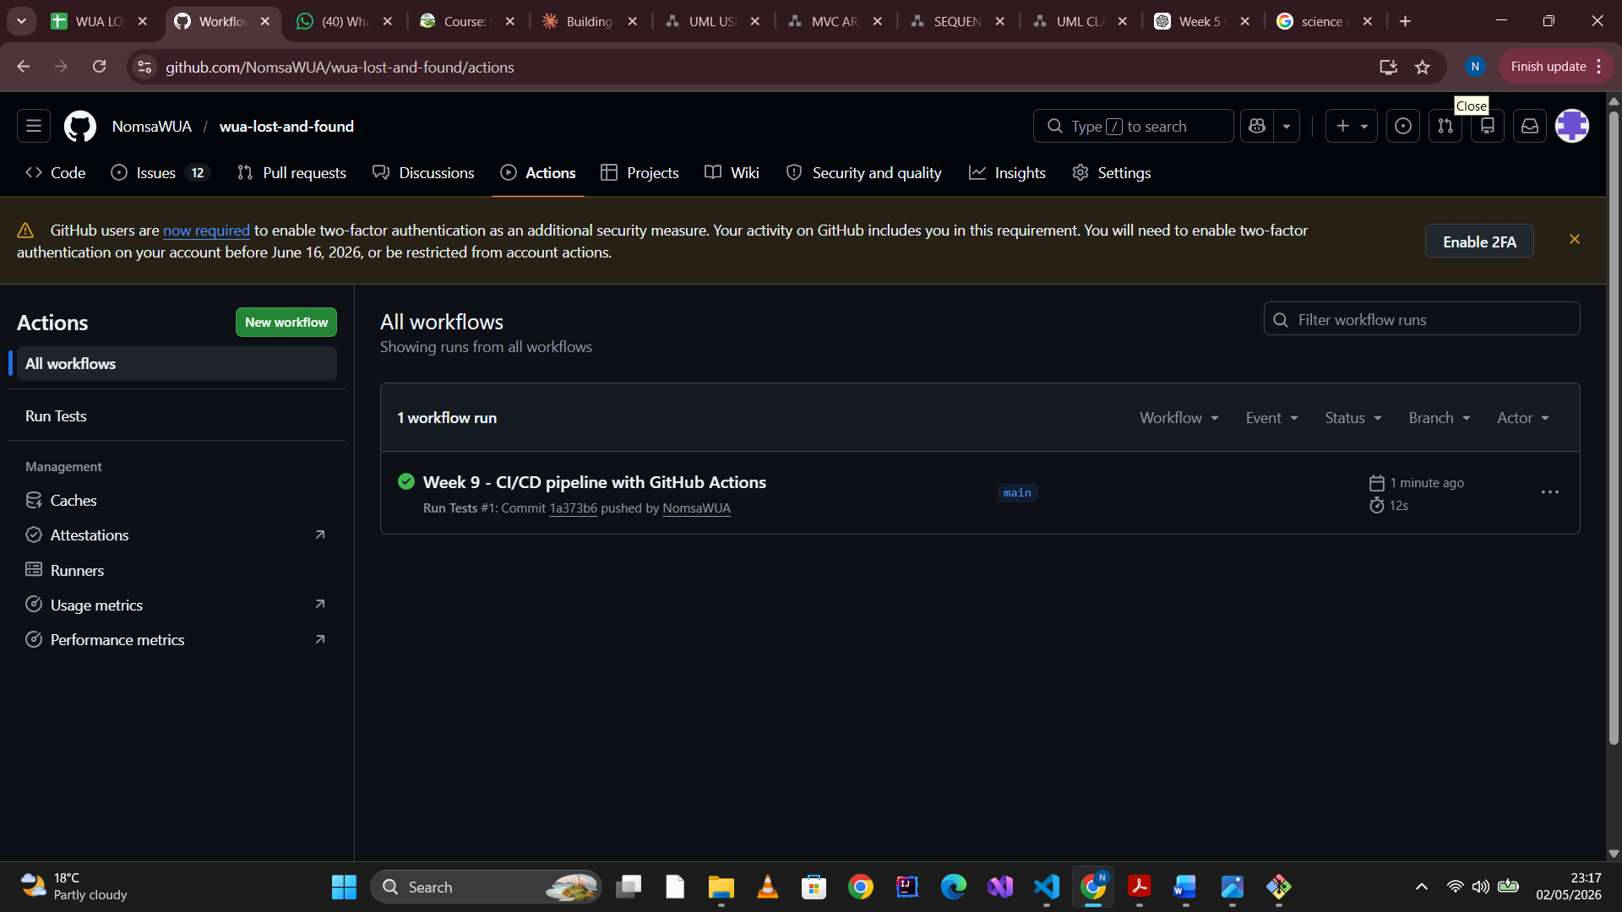

Week 10: Project Scheduling & Task Tracking
Lab 10: Sprint Planning with Jira/Trello
- • Create a sprint backlog (5–7 tasks from your product backlog).
- • Estimate effort using Planning Poker (1, 2, 3, 5, 8 story points).
- • Assign tasks to team members and set a 1-week sprint goal.

